AI-Based Warehouse Space and Material Optimization
Student Hackathon Project Report
1. Problem Understanding
Modern warehouses face major operational bottlenecks due to suboptimal inventory placement. High-demand items placed far from dispatch areas cause excessive travel time, increased material handling costs, and poor picking throughput. Concurrently, available bin capacities are often underutilized due to mismatched dimensional assignments. The goal of this project is to build an intelligent, lightweight AI/heuristic optimization system that dynamically determines ideal storage slots to minimize picking distance and optimize cubic space utilization without requiring GPUs or paid external APIs.
2. Methodology & Algorithm Design
A. Priority Velocity Scoring
Products are ranked based on their turnover rate and picking frequency using the formula:
Priority Score = Daily Demand * Picking Frequency Weight

- High Frequency: Weight = 3
- Medium Frequency: Weight = 2
- Low Frequency: Weight = 1
B. Greedy Capacity-Constrained Slotting Algorithm
- Product Prioritization: All inventory SKUs are sorted in descending order based on their Priority Score (ties resolved using daily demand and unit volume).
- Rack Proximity Sorting: Warehouse locations are sorted in ascending order of physical distance from the primary dispatch/packing point (accessibility tier used as tie-breaker).
- Volumetric Feasibility Matching: For each product, the algorithm greedily assigns the closest rack where Remaining Rack Capacity ≥ Product Volume.
- Fallback Handling: If no available rack satisfies the volumetric boundary, the item is tagged as NO_SLOT_AVAILABLE and remains in its original position to ensure operational continuity.
3. System Architecture & Components
- Data Processing Module: Cleans raw CSVs, recalculates volume from dimensions (L * W * H), coerces invalid numeric fields, and handles unknown rack mappings.
- Optimization Engine: Implements the priority-scoring and capacity-matching algorithm in pure Python using Pandas and NumPy.
- Interactive Web Dashboard: A responsive Streamlit frontend providing CSV upload capability, instant recommendation tables, and live comparison dashboards.
- Evaluation Framework: Computes baseline vs optimized travel distances, space utilization percentages, and assignment feasibility.
4. Experimental Results & Performance Metrics
Testing with 40 inventory products across 50 warehouse candidate racks produced the following quantifiable improvements
- Daily Picking Distance: Baseline ~47,916 m -> Optimized 5,606 m (88.3% Reduction, 42,310 m saved/day)
- Warehouse Space Utilization: Baseline 13.5% -> Optimized 73.4% (+59.9 percentage points improvement)
- Feasibility Rate: 100.0% (0 unplaced items, Full match)
- Racks Occupied: Consolidated from 26 Racks down to 3 Racks (-23 racks saved)

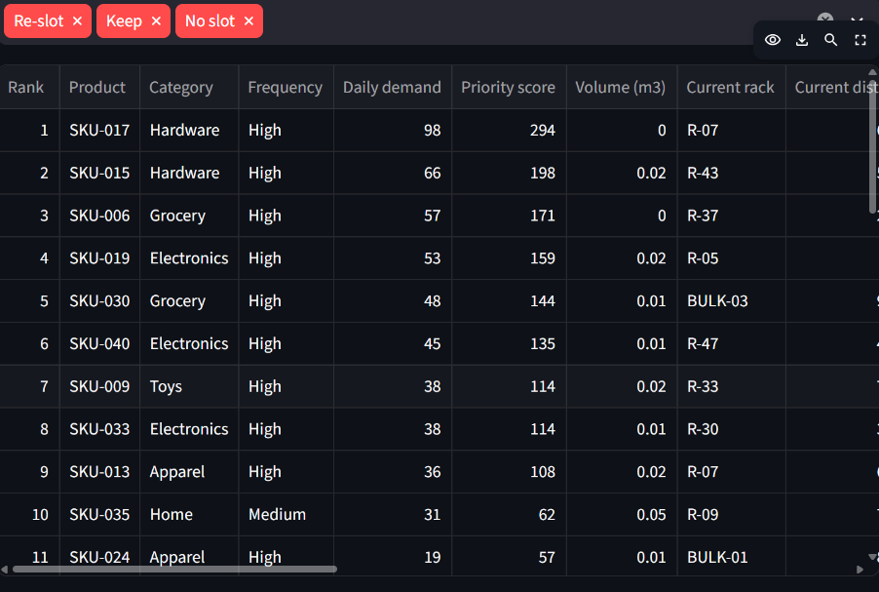

BEFORE AND AFTER
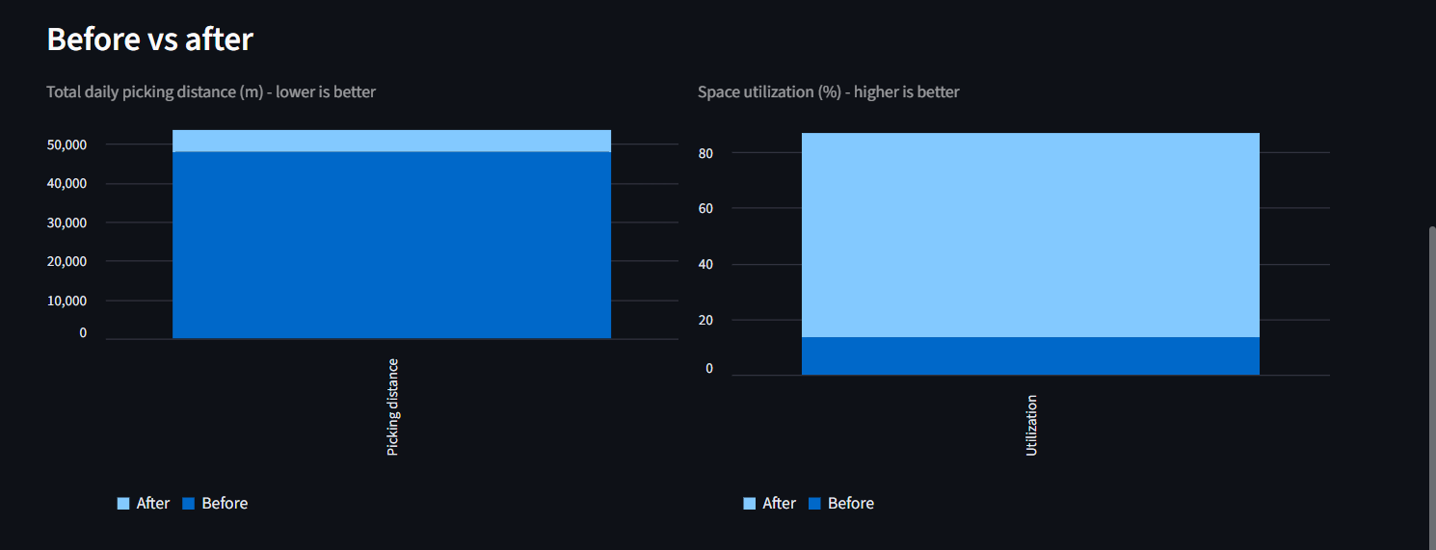
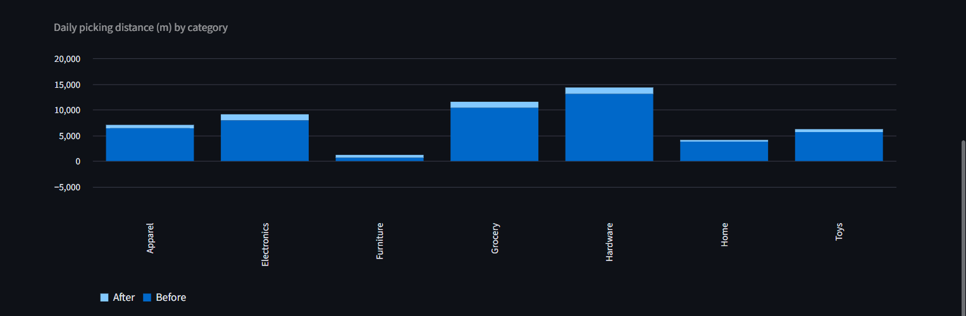

5. Constraints & Compliance
- Compute Constraints: Zero dependency on paid external APIs or GPUs; fully runs locally on standard CPU in milliseconds.
- Storage Feasibility: 100% compliant with physical volumetric capacity constraints without overflow.
- Data Integrity: Handled invalid, duplicate, and missing dimensional inputs safely.

6. Limitations & Future Roadmap
- 3D Spatial Packing: Future versions can integrate 3D bounding box orientation algorithms beyond pure volume aggregation.
- Predictive Demand Forecasting: Time-series ML models (e.g., ARIMA, XGBoost) can be integrated to anticipate seasonal demand spikes before slotting changes.
- Batch Picking Optimization: Extending the routing engine to solve Travelling Salesperson Problem (TSP) multi-item picking loops.

